Year 12 General Human Biology
Pathogens

Task 5: Kitchen hygiene

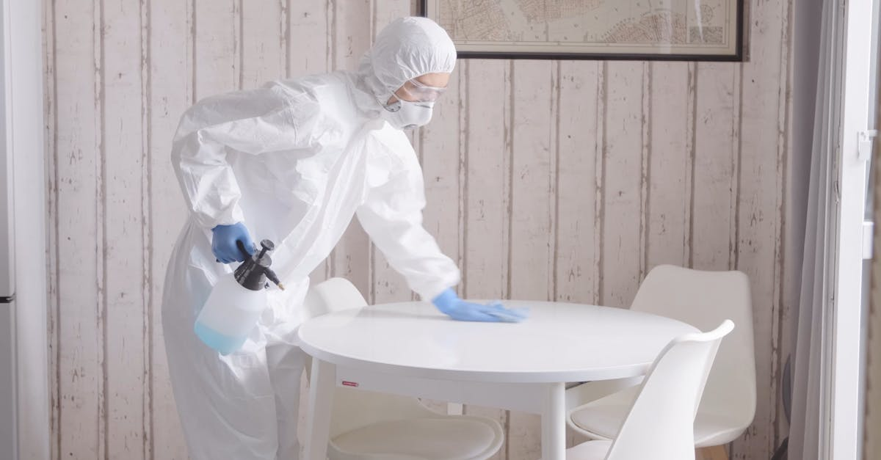
Logbook
General

Name: __________________________________
Teacher: Mrs Cunningham
Contents Page
Page # | Description

CHECK POINTS
☐ Week 2 Research topic and construct question for investigation
☐ Week 2 Design procedure. Submit draft method*
☐ Week 2-4 Conduct investigation
☐ Week 5 Analyse data, draw conclusions, and evaluate evidence
☐ Week 5 Submit draft written report
☐ Week 6 Poster presentation*
☐ Week 6 Submit final written report

* The items marked with an asterisk require only one group document to be submitted.

Authentication strategies:
The teacher will:
- provide class time for task completion.
- monitor progress at specified check points.
- collect and annotate drafts.
- monitor student contributions to the group task.

The student will:
- maintain a logbook to document their progress.
- complete self and peer assessments of contributions to the group task
- acknowledge all sources.

Part A: Background Research
Chosen type of kitchen being studied:
_______________________________________________________________________________________________________________________________________________________________________________________________________________
Specific information about chosen kitchen being studied:
__________________________________________________________________________________________________________________________________________
_______________________________________________________________________________________________________________________________________________________________________________________________________________
_____________________________________________________________________
Hygiene practices for kitchen being studied:
____________________________________________________________________________________________________________________________________________________________________________________________________________________________________________________________________________________________________________________________________________________________________________________________________________________________________________________________________________________________________________________________________________________________________________________________________________________________________________________________________________________________________________________________________________________________________________________________________________________________________________________________________________________________________________________________________________________________________________________________________________________________________________________________________________________________________________________________________________________________________________________________________________________________________________________________________________________________________________________________________________________________________________________________________________________________________
______________________________________________________________________________________________________________________________________________________________________________________________________________________________________________________________________________________________________________________________________________________________________________________________________________________________________________________________________________________________________________________________________________________________________________________________________________________________________________________________________________________________________________________________________________________________________________________________________________________________________________________________________________________________________________________________________________________________________________________________________
_____________________________________________________________________

Hygiene practice recommendations for chosen kitchen being studied:
_____________________________________________________________________________________________________________________________________________________________________________________________________________________________________________________________________________________________________________________________________________________________________________________________________________________________________________________________________________________________________________________________________________________________________________________________________________________________________________________________________________________________________________________________________________________________________________________________________________________________________________________________________________________________________________________________________________________________________________________________________________________________________________________________________________________________________________________________________________________________________________________________________________________________________________________________________________________________________________________________________________________________________________________________________________________________________________________________________________________________________________________________________________________________________________________________________________________________________________________________________________________________________________________________________________________________________________________________________________________________________________________________________________________________________________________________________________________________________________________________________________________________________________________________________________________________________________________________________________________________________________________________________________________________________________________________________________________________________________________________________________________________________________________________________________________________________________________________________________________________________________________________________________________________________________________________________________________________________________________________________________________________________________________________________________________________________________________________________________________________________________________________________________________________________________________________________________________________________________________________________________________________________________________________________________________________________________________________________________________________________________________________________________________________________________________________________________________________________________________________________________________________________________________________________________________________________________________________________________________________________________________
References for the research conducted:
________________________________________________________________________________________________________________________________________________________________________________________________________________________________________________________________________________________________________________________________________________________________________________________________________________________________________________________________________________________________________________________________________________________________________________________________________________________________________________________________________________________________________________________________________________________________________________________________________________________________________________________________________________________________________________________________________________________________________________________________________________________________________________________________________________________________________________________________________________________________________________________________________________________________________________________________________________________________________________________________________________________________________________________________________________________________________________________________________________________________________________________________________________________________________________________________________________________________________________________________________________________________________________________
Additional Research:
_____________________________________________________________________________________________________________________________________________________________________________________________________________________________________________________________________________________________________________________________________________________________________________________________________________________________________________________________________________________________________________________________________________________________________________________________________________________________________________________________________________________________________________________________________________________________________________________________________________________________________________________________________________________________________________________________________________________________________________________________________________________________________________________________________________________________________________________________________________________________________________________________________________________________________________________________________________________________________________________________________________________________________________________________________________________________________________________________________________________________________________________________________________________________________________________________________________________________________________________________________________________________________________________________________________________________________________________________________________________________________________________________________________________________________________________________________________________________________________________________________________________________________________________________________________________________________________________________________________________________________________________________________________________________________________________________________________________________________________________________________________________________________________________________________________________________________________________________________________________________________________________________________________________________________________________________________________________________________________________________________________________________________________________________________________________________________________________________________________________________________________________________________________________________________________________________________________________________________________________________________________________________________________________________________________________________________________________________________________________________________________________________________________________________________________________________________________________________________________________________________________________________________________________________________________________________________________________________________________________________________________________
References for the additional research:
________________________________________________________________________________________________________________________________________________________________________________________________________________________________________________________________________________________________________________________________________________________________________________________________________________________________________________________________________________________________________________________________________________________________________________________________________________________________________________________________________________________________________________________________________________________________________________________________________________________________________________________________________________________________________________________________________________________________________________________________________________________________________________________________________________________________________________________________________________________________________________________________________________________________________________________________________________________________________________________________________________________________________________________________________________________________________________________________________________________________________________________________________________________________________________________________________________________________________________________________________________________________________________________
Investigation aim:
____________________________________________________________________________________________________________________________________________________________________________________________________________________________________________________________________________________
Hypothesis (if/then statement):
____________________________________________________________________________________________________________________________________________________________________________________________________________________________________________________________________________________
Independent variable (what are you changing):
_______________________________________________________________________________________________________________________________________________________________________________________________________________
Dependant variable (what are you measuring):
_______________________________________________________________________________________________________________________________________________________________________________________________________________
Control variables (what are you keeping the same):
_________________________________________________________________________________________________________________________________________________________________________________________________________________________________________________________________________________________________________________________________________________________
Why do control variables need to stay the same?
____________________________________________________________________________________________________________________________________________________________________________________________________________________________________________________________________________________
Additional Research:
___________________________________________________________________________________________________________________________________________________________________________________________________________________________________________________________________________________________________________________________________________________________________________________________________________________________________________________________________________________________________________________________________________________________________________________________________________________________________________________________________________________________________________________________________________________________________________________________________________________________________________________________________________________________________________________________________________________________________________________________________________________________________________________________________________________________________________________________________________________________________________________________________________________________________________________________________________________________________________________________________________________________________________________________________________________________________________________________________________________________________________________________________________________________________________________________________________________________________________________________________________________________________________________________________________________________________________________________________________________________________________________________________________________________________________________________________________________________________________________________________________________________________________________________________________________________________________________________________________________________________________________________________________________________
References for the additional investigation research:
________________________________________________________________________________________________________________________________________________________________________________________________________________________________________________________________________________________________________________________________________________________________________________________________________________________________________________________________________________________________________________________________________________________________________
__________________________________________________________________________________________________________________________________________
Part B: Planning and conducting the investigation.
Planning your investigation notes:
___________________________________________________________________________________________________________________________________________________________________________________________________________________________________________________________________________________________________________________________________________________________________________________________________________________________________________________________________________________________________________________________________________________________________________________________________________________________________________________________________________________________________________________________________________________________________________________________________________________________________________________________________________________________________________________________________________________________________________________________________________________________________________________________________________________________________________________________________________________________________________________________________________________________________________________________________________________________________________________________________________________________________________________________________________________________________________________________________________________________________________________________________________________________________________________________________________________________________________________
How are you performing this investigation?
_____________________________________________________________________________________________________________________________________________________________________________________________________________________________________________________________________________________________________________________________________________________________________________________________________________________________
__________________________________________________________________________________________________________________________________________________________________________________________________________________________________________________________________________________________________________________________________________________________________________________________________________________________________________________________________________________________________________________________________________________________________________________________________________________________________________________________________________________________________________________________________________________________________________________________________________________________________________________________________________________________________________________________________________________________________________________________________________________________________________________________________________________________________________________________________________________________________________________________________________________________________________________________________________________________
What do you need to perform this investigation?
___________________________________________________________________________________________________________________________________________________________________________________________________________________________________________________________________________________________________________________________________________________________________________________________________________________________________________________________________________________________________________________________________________________________________________________________________________________________________________________________________________________________________________________________________________________________________________________________________________________________________________________________________________________________________________________________________________________________________________________________________________________________________________________________________________
_____________________________________________________________________________________________________________________________________________________________________________________________________________________________________________________________________________________________________________________________________________________________________________________________________________________________________________________________________________________________________________________________________________________________________________________________________________________________________________
How will you collect your data?
_______________________________________________________________________________________________________________________________________________________________________________________________________________________________________________________________________________________________________________________________________________________________________________________________________________________________________________________________________________________________________________________________________________________________________________________________________________________________________________________________________________________________________________________________________________________________________________________
How will you record your data?
_____________________________________________________________________________________________________________________________________________________________________________________________________________________________________________________________________________________________________________________________________________________________________________________________________________________________________________________________________________________________________________________________________________________________________________________________________________________________________________

What are some safety considerations you need to keep in mind during this investigation?
______________________________________________________________________________________________________________________________________________________________________________________________________________________________________________________________________________________________________________________________________________________________________________________________________________________________
What are some safety precautions you can take?
_____________________________________________________________________________________________________________________________________________________________________________________________________________________________________________________________________________________________________________________________________________________________________________________________________________________________
What equipment do you need to be careful of?
__________________________________________________________________________________________________________________________________________ ___________________________________________________________________________________________________________________________________________________________________________________________________________________________________________________________________________________________________________________________________________________________________________________________________________________________________________________________________________________________________
RISK ASSESSMENT
Identify possible hazards.
______________________________________________________________________________________________________________________________________________________________________________________________________________________________________________________________________________________________________________________________________________________________________________________________________________________________
__________________________________________________________________________________________________________________________________________ Identify possible risks associated with these hazards.
____________________________________________________________________________________________________________________________________________________________________________________________________________________________________________________________________________________
_______________________________________________________________________________________________________________________________________________________________________________________________________________ Identify mitigations to be put into place.
_______________________________________________________________________________________________________________________________________________________________________________________________________________
_____________________________________________________________________
Materials:
Quantity | Item

Method / Procedure:
Step 1:
____________________________________________________________________________________________________________________________________________________________________________________________________________________________________________________________________________________
Step 2:
____________________________________________________________________________________________________________________________________________________________________________________________________________________________________________________________________________________
You continue….
_____________________________________________________________________________________________________________________________________________________________________________________________________________________________________________________________________________________________________________________________________________________________________________________________________________________________
_______________________________________________________________________________________________________________________________________________________________________________________________________________________________________________________________________________________________________________________________________________________________________________________________________________________________________________________________________________________________________________________________________________________________________________________________________________________________________________________________________________________________________________________________________________________________________________________
__________________________________________________________________________________________________________________________________________
__________________________________________________________________________________________________________________________________________
__________________________________________________________________________________________________________________________________________
__________________________________________________________________________________________________________________________________________
__________________________________________________________________________________________________________________________________________
__________________________________________________________________________________________________________________________________________
__________________________________________________________________________________________________________________________________________
__________________________________________________________________________________________________________________________________________
__________________________________________________________________________________________________________________________________________
Create a results table for all your observations and raw data:

Draw any observations, images, or diagrams here:

Part C: Data processing and analysis
Graph your results:
☐ Use a title
☐ Even scale on x and y axis
☐ Label your x and y axis
☐ Correct units of measurement
☐
☐ Plot your data accurately
☐ Use a key (if required)

Use averages of data

Use the graph paper below. If you make a mistake, get graph paper from your teacher and staple onto this page. 
What patterns can you see in your data?
_________________________________________________________________________________________________________________________________________________________________________________________________________________________________________________________________________________________________________________________________________________________________________________________________________________________________________________________________________________________________________________________________________________________________________________________________________________________________________________________________________________________________________________________________________________________________________________________________________________________________________________________________________________________________________________________________
What relationships can you see between your independent and dependent variables?
_______________________________________________________________________________________________________________________________________________________________________________________________________________
______________________________________________________________________________________________________________________________________________________________________________________________________________________________________________________________________________________________________________________________________________________________________________________________________________________________
What else does your data tell you?
_____________________________________________________________________________________________________________________________________________________________________________________________________________________________________________________________________________________________________________________________________________________________________________________________________________________________________________________________________________________________________________________________________________________________________________________________________________________________________________
Find supporting scientific evidence to explain your findings:
___________________________________________________________________________________________________________________________________________________________________________________________________________________________________________________________________________________________________________________________________________________________________________________________________________________________________________________________________________________________________
______________________________________________________________________________________________________________________________________________________________________________________________________________________________________________________________________________________________________________________________________________________________________________________________________________________________
Was your hypothesis supported or rejected?
____________________________________________________________________________________________________________________________________________________________________________________________________________________________________________________________________________________Justify your conclusion, make sure to refer to your data and directly relate it to your hypothesis:
_______________________________________________________________________________________________________________________________________________________________________________________________________________
_____________________________________________________________________________________________________________________________________________________________________________________________________________________________________________________________________________________________________________________________________________________________________________________________________________________________
_______________________________________________________________________________________________________________________________________________________________________________________________________________
_________________________________________________________________________________________________________________________________________________________________________________________________________________________________________________________________________________________________________________________________________________________
Was your experiment accurate, reliable, and valid?
____________________________________________________________________________________________________________________________________________________________________________________________________________________________________________________________________________________
Why/Why not?
_______________________________________________________________________________________________________________________________________________________________________________________________________________
______________________________________________________________________________________________________________________________________________________________________________________________________________________________________________________________________________________________________________________________________________________________________________________________________________________________
_______________________________________________________________________________________________________________________________________________________________________________________________________________
______________________________________________________________________________________________________________________________________________________________________________________________________________________________________________________________________________________________________________________________________________________________________________________________________________________________
What improvements/changes would you make for next time?
___________________________________________________________________________________________________________________________________________________________________________________________________________________________________________________________________________________________________________________________________________________________________________________________________________________________________________________________________________________________________
_____________________________________________________________________________________________________________________________________________________________________________________________________________________________________________________________________________________________________________________________________________________________________________________________________________________________________________________________________________________________________________________________________________________________________________________________________________________________________________
___________________________________________________________________________________________________________________________________________________________________________________________________________________________________________________________________________________________________________________________________________________________________________________________________________________________________________________________________________________________________Part D: Written report
Your write-up should be written in third person (without using inclusive language such as I, we, our, etc.) and written in past tense.
Example:
Correct - 200mL of distilled water was poured into a 500 mL beaker.
Pour 200mL water in a beaker. (direction/command)
Incorrect - I poured 200mL of distilled water in a beaker. (First person)

- Title – Choose a name for the experiment. Your title should be informative and describe the experiment.
- Aim – What is it that you are trying to find out/ What is the purpose of your experiment? Provide extra details not included in your title.
- Hypothesis – Includes independent and dependent variables and shows the relationship between them.
- Equipment – this should be a vertical list (like a shopping list) of all the equipment you need to carry out this experiment.

Variables –
- Independent Variable: State what you will change.
- Dependent Variable: State what you will measure.
- Control Variables: List at least three things you will keep the same to make it a fair test. Make sure you include all relevant details. Control variables must be more than one word. You must state why they must be controlled.

- Method – The numbered steps you will follow to complete this experiment. Written as a vertical list (like a recipe).
- Diagram – This helps to explain your method. Must be 2D, labelled and completed in pencil, using a ruler.

Results –
- Table – Include what you measured (dependent variable) and observations that you have made. Needs a descriptive title and clear column headings with the units used.
- Graph – Draw a graph to help explain your results visually. Your graph should have descriptive titles and clearly labelled axis with units. Dependent variable should always be on the Y axis and independent variable on the X axis (unless measuring over time then time should be on the X axis).

- Conclusion –State whether your results support or don’t support your hypothesis.
- Discussion - Discuss what you have found out in this experiment by using your own results and try to explain scientifically why you got these results.
- Evaluation – State things that went wrong or problems that occurred during the experiment. For each problem suggest ways to improve the experiment.

- Referencing – Make sure to correctly add all references throughout your report, and a reference page at the end.
Try using a website like https://www.mybib.com/tools/apa-citation-generator

SELF ASSESSMENT
Assessment Criteria | Description | Self-Assessment Score (1-5) | Comments and Feedback
Research and Data Collection | Ability to gather relevant information, conduct experiments, and collect data effectively.
Analysis and understanding | Capability to analyze collected data accurately and grasp complex concepts related to the investigation.
Teamwork and Collaboration | Effectiveness in working with the team, sharing responsibilities, and supporting others.
Problem Solving and Innovation | Creativity in addressing challenges and ability to propose innovative solutions.
Communication and Presentation | Clarity and effectiveness in communicating findings and presenting results.

Scoring Guide
- 1 (Poor): Significantly below expectations; requires substantial improvement.
- 2 (Fair): Below expectations; needs noticeable improvement.
- 3 (Good): Meets basic expectations; satisfactory performance.
- 4 (Very Good): Exceeds expectations; very good performance with minor areas for improvement.
- 5 (Excellent): Far exceeds expectations; outstanding performance.

Instructions for Use:
- Individual Self-Assessment: Each team member should independently rate their own contributions in each category, providing scores and thoughtful comments on their performance and areas for growth.

PEER ASSESSMENTS
Assessment Criteria | Description | Peer Assessment Score (1-5) | Comments and Feedback
Research and Data Collection | Ability to gather relevant information, conduct experiments, and collect data effectively.
Analysis and understanding | Capability to analyze collected data accurately and grasp complex concepts related to the investigation.
Teamwork and Collaboration | Effectiveness in working with the team, sharing responsibilities, and supporting others.
Problem Solving and Innovation | Creativity in addressing challenges and ability to propose innovative solutions.
Communication and Presentation | Clarity and effectiveness in communicating findings and presenting results.

Peer Name: _______________________________________________________

Scoring Guide
- 1 (Poor): Significantly below expectations; requires substantial improvement.
- 2 (Fair): Below expectations; needs noticeable improvement.
- 3 (Good): Meets basic expectations; satisfactory performance.
- 4 (Very Good): Exceeds expectations; very good performance with minor areas for improvement.
- 5 (Excellent): Far exceeds expectations; outstanding performance.

Instructions for Use:
- Peer Assessment: Team members then anonymously rate each other's contributions using the same criteria and scoring guide, offering constructive feedback in the comments section
PEER ASSESSMENTS
Assessment Criteria | Description | Peer Assessment Score (1-5) | Comments and Feedback
Research and Data Collection | Ability to gather relevant information, conduct experiments, and collect data effectively.
Analysis and understanding | Capability to analyze collected data accurately and grasp complex concepts related to the investigation.
Teamwork and Collaboration | Effectiveness in working with the team, sharing responsibilities, and supporting others.
Problem Solving and Innovation | Creativity in addressing challenges and ability to propose innovative solutions.
Communication and Presentation | Clarity and effectiveness in communicating findings and presenting results.

Peer Name: _______________________________________________________

Scoring Guide
- 1 (Poor): Significantly below expectations; requires substantial improvement.
- 2 (Fair): Below expectations; needs noticeable improvement.
- 3 (Good): Meets basic expectations; satisfactory performance.
- 4 (Very Good): Exceeds expectations; very good performance with minor areas for improvement.
- 5 (Excellent): Far exceeds expectations; outstanding performance.

Instructions for Use:
- Peer Assessment: Team members then anonymously rate each other's contributions using the same criteria and scoring guide, offering constructive feedback in the comments section.

PEER ASSESSMENTS
Assessment Criteria | Description | Peer Assessment Score (1-5) | Comments and Feedback
Research and Data Collection | Ability to gather relevant information, conduct experiments, and collect data effectively.
Analysis and understanding | Capability to analyze collected data accurately and grasp complex concepts related to the investigation.
Teamwork and Collaboration | Effectiveness in working with the team, sharing responsibilities, and supporting others.
Problem Solving and Innovation | Creativity in addressing challenges and ability to propose innovative solutions.
Communication and Presentation | Clarity and effectiveness in communicating findings and presenting results.

Peer Name: _______________________________________________________

Scoring Guide
- 1 (Poor): Significantly below expectations; requires substantial improvement.
- 2 (Fair): Below expectations; needs noticeable improvement.
- 3 (Good): Meets basic expectations; satisfactory performance.
- 4 (Very Good): Exceeds expectations; very good performance with minor areas for improvement.
- 5 (Excellent): Far exceeds expectations; outstanding performance.

Instructions for Use:
- Peer Assessment: Team members then anonymously rate each other's contributions using the same criteria and scoring guide, offering constructive feedback in the comments section.
PEER ASSESSMENTS
Assessment Criteria | Description | Peer Assessment Score (1-5) | Comments and Feedback
Research and Data Collection | Ability to gather relevant information, conduct experiments, and collect data effectively.
Analysis and understanding | Capability to analyze collected data accurately and grasp complex concepts related to the investigation.
Teamwork and Collaboration | Effectiveness in working with the team, sharing responsibilities, and supporting others.
Problem Solving and Innovation | Creativity in addressing challenges and ability to propose innovative solutions.
Communication and Presentation | Clarity and effectiveness in communicating findings and presenting results.

Peer Name: _______________________________________________________

Scoring Guide
- 1 (Poor): Significantly below expectations; requires substantial improvement.
- 2 (Fair): Below expectations; needs noticeable improvement.
- 3 (Good): Meets basic expectations; satisfactory performance.
- 4 (Very Good): Exceeds expectations; very good performance with minor areas for improvement.
- 5 (Excellent): Far exceeds expectations; outstanding performance.

Instructions for Use:
- Peer Assessment: Team members then anonymously rate each other's contributions using the same criteria and scoring guide, offering constructive feedback in the comments section.
PEER ASSESSMENTS
Assessment Criteria | Description | Peer Assessment Score (1-5) | Comments and Feedback
Research and Data Collection | Ability to gather relevant information, conduct experiments, and collect data effectively.
Analysis and understanding | Capability to analyze collected data accurately and grasp complex concepts related to the investigation.
Teamwork and Collaboration | Effectiveness in working with the team, sharing responsibilities, and supporting others.
Problem Solving and Innovation | Creativity in addressing challenges and ability to propose innovative solutions.
Communication and Presentation | Clarity and effectiveness in communicating findings and presenting results.

Peer Name: _______________________________________________________

Scoring Guide
- 1 (Poor): Significantly below expectations; requires substantial improvement.
- 2 (Fair): Below expectations; needs noticeable improvement.
- 3 (Good): Meets basic expectations; satisfactory performance.
- 4 (Very Good): Exceeds expectations; very good performance with minor areas for improvement.
- 5 (Excellent): Far exceeds expectations; outstanding performance.

Instructions for Use:
- Peer Assessment: Team members then anonymously rate each other's contributions using the same criteria and scoring guide, offering constructive feedback in the comments section

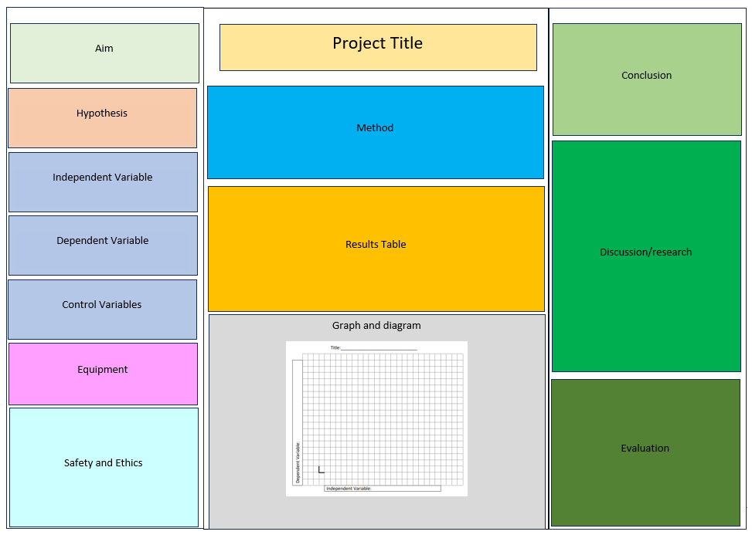
Part E: Poster Presentation

